

**What is stock market?**

The stock market is a dynamic financial marketplace where individuals and institutions buy and sell ownership stakes in publicly traded companies. Through this exchange of shares, investors can participate in the growth and success of businesses, while companies can raise capital to fund their operations and expansion. Stock markets facilitate the trading of securities, such as stocks and bonds, through regulated exchanges, where prices are determined by supply and demand. Investors engage in various strategies, from long-term investing to short-term trading, aiming to achieve financial goals and capitalize on market opportunities. Overall, the stock market serves as a vital component of the global economy, providing liquidity, investment opportunities, and a mechanism for companies to access funding for growth.

**How to trade stocks?**

**Educate Yourself:**

* Learn the basics of the stock market, including terminology, trading mechanisms, and risk management.
* Utilize educational resources such as books, online courses, and tutorials.

**Open a Brokerage Account:**

* Choose a reputable brokerage firm and open an account.
* Consider factors like trading fees, account minimums, research tools, and customer service.

**Develop a Trading Plan:**

* Define your trading objectives, risk tolerance, and strategy (e.g., day trading, swing trading, long-term investing).
* Determine entry and exit criteria, position sizing rules, and risk management strategies.

**Research Stocks:**

* Conduct thorough research on potential trading opportunities.
* Analyze company fundamentals, financial statements, industry trends, and market sentiment.
* Use fundamental analysis, technical analysis, or a combination of both to assess stocks' potential.

**Execute Trades:**

* Log in to your brokerage account and place your trades through the trading platform.
* Choose the appropriate order type (market orders, limit orders, stop orders) based on your strategy and risk management preferences.
* Double-check your order details before submitting to ensure accuracy.

**Monitor Your Positions:**

* Keep an eye on your positions regularly to stay informed about market developments and price movements.
* Use your trading plan to determine when to take profits or cut losses.
* Adjust stop-loss orders and profit targets as needed to manage risk effectively.

**Review and Learn:**

* Keep a trading journal to record your trades, including entry and exit points, reasons for the trade, and outcomes.
* Analyze your trades regularly to identify patterns, strengths, and areas for improvement.
* Continuously learn and adapt your trading strategy based on your experiences.

**Manage Risk:**

* Implement risk management strategies to protect your capital.
* Use position sizing, stop-loss orders, and diversification to manage risk effectively.
* Avoid emotional decision-making and never risk more than you can afford to lose on any single trade.

Trading stocks can be both rewarding and challenging, so it's important to approach it with patience, discipline, and continuous learning. If you're new to trading, consider starting with small positions or paper trading to gain experience before committing real capital. Additionally, seeking guidance from experienced traders or financial advisors can be beneficial in navigating the complexities of the stock market.

**What is technical indicator?**

A technical indicator is a quantitative tool used by traders and analysts to interpret and forecast price movements in financial markets. These indicators are typically derived from historical price and volume data, employing mathematical formulas to generate visual representations on price charts. By analyzing these indicators alongside price action, traders can identify patterns, trends, and potential entry or exit points for trades. Technical indicators come in various forms, including moving averages, oscillators, momentum indicators, and volatility measures, each offering unique insights into market dynamics. While technical analysis forms a cornerstone of many trading strategies, it's essential for traders to combine these indicators with other forms of analysis and risk management techniques for informed decision-making.

Here we will discuss two technical indicators which are:

1. Average Directional Index (ADX)
2. Directional Moving Index (DMI)
3. **Average Directional Index (ADX):**

The Average Directional Index (ADX) is a popular technical analysis tool used to measure the strength of a trend. Developed by J. Welles Wilder Jr., the ADX helps traders identify whether a market is trending or ranging, as well as the strength of the trend. It does not provide information about the direction of the trend, only its strength.

**Components of ADX:**

1. **Positive Directional Indicator (+DI):**

This component measures the strength of upward price movement. It is calculated based on the difference between today's high and yesterday's high. If today's high is higher than yesterday's high, the difference is positive, otherwise, it's zero.

1. **Negative Directional Indicator (-DI):**

This component measures the strength of downward price movement. It is calculated similarly to +DI but based on lows rather than highs. If today's low is lower than yesterday's low, the difference is positive, otherwise, it's zero.

1. **Directional Movement Index (DX):**

This is derived from the +DI and -DI and represents the strength of the current trend. It is calculated using the formula:

$$DX=\frac{Absolute value \left(\left(+DI\right)- \left(-DI\right)\right)}{\left(+DI\right)+\left(-DI\right)}$$

where +DI and -DI are the positive and negative directional indicators, respectively. The DX ranges from 0 to 100.

1. **Average Directional Index (ADX):**

The ADX is calculated by smoothing the DX values over a specified period using an exponential moving average (EMA). The typical period used is 14 days. The ADX ranges from 0 to 100, with higher values indicating a stronger trend.

**What Does the ADX Tell You?**

The ADX, negative directional indicator (-DI), and positive directional indicator (+DI) are momentum indicators. The ADX helps investors determine trend strength, while -DI and +DI help determine trend direction.

The ADX identifies a strong trend when the ADX is over 25 and a weak trend when

the ADX is below 20. Crossovers of the -DI and +DI lines can be used to generate

trade signals. For example, if the +DI line crosses above the -DI line and the ADX is

above 20, or ideally above 25, then that is a potential signal to buy. On the other

hand, if the -DI crosses above the +DI, and the ADX is above 20 or 25, then that is

an opportunity to enter a potential short trade.

Crosses can also be used to exit current trades. **For example**, if long, exit when the

-DI crosses above the +DI. Meanwhile, when the ADX is below 20 the indicator is

signaling that the price is trendless and that it might not be an ideal time to enter

a trade.

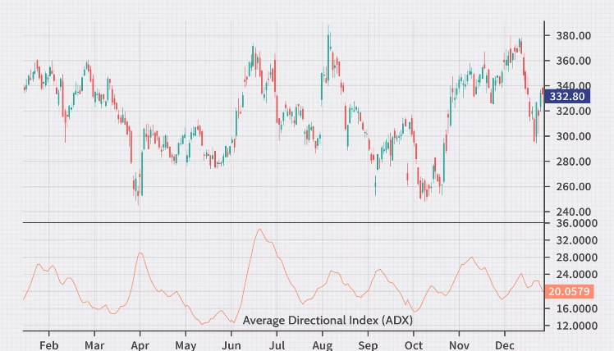

**Why should we use ADX indicator?**

* **Objective Trend Strength Measurement:**

ADX provides a numerical measure of trend strength, allowing traders to objectively assess whether a market is trending or ranging. This objective measurement helps traders avoid emotional biases and make data-driven trading decisions.

* **Trend Confirmation and Filtering:**

ADX can confirm the presence of a trend identified by other technical indicators or trading strategies. By filtering out market noise and focusing on significant price movements, ADX enhances the reliability of trading signals, increasing the confidence level in trade entries and exits.

* **Risk Management Enhancement:**

Understanding trend strength with ADX enables traders to adjust their risk management strategies accordingly. In strong trending markets, traders may opt for wider profit targets and tighter stop-loss levels to capitalize on trends while minimizing potential losses. ADX serves as a valuable tool for optimizing risk-reward ratios and improving overall trading performance.

* **Versatility and Adaptability:**

ADX can be applied across various financial instruments and timeframes, making it suitable for a wide range of trading styles and strategies. Whether trading stocks, forex, commodities, or indices, ADX provides valuable insights into market dynamics, helping traders adapt to changing market conditions and improve their overall trading performance.

**Limitations of the ADX indicator:**

Despite its advantages, the ADX also has some limitations:

* **Lagging Nature:** As a trend-following indicator, the ADX tends to lag behind the actual price movement. It might not always provide timely signals, potentially leading to late entries or exits.
* **No Directional Bias:** The ADX only measures the strength of a trend, not its direction. Traders must use other indicators or techniques to determine whether the trend is bullish or bearish.
* **False Signals:** The ADX may generate false signals like all technical indicators, particularly in choppy or sideways markets. This highlights the importance of using the ADX in conjunction with other indicators to minimize false signals.

1. **Directional Moving Index (DMI):**

The Directional Movement Index (DMI) is a technical analysis indicator utilized by traders to assess the strength and direction of a trend in a financial instrument. It was developed by **J. Welles Wilder** and introduced in his book **"New Concepts in Technical Trading Systems"** in **1978**. DMI is composed of two lines: the Positive Directional Indicator (+DI) and the Negative Directional Indicator (-DI). These lines are overlaid on a price chart to help traders identify the trend direction and its strength.

**Components of ADX:**

Here's a detailed breakdown of the components and how the DMI indicator works:

1. **Positive Directional Indicator (+DI):**

This line measures the strength of upward price movement.

It calculates the difference between the current high and the previous high. If

the current high is higher than the previous high, the difference is considered

positive and added to the indicator. Otherwise, it's zero. The resulting values

are smoothed over a specific period (typically 14 periods) to generate a

moving average of the positive directional movement.

$$+DI=\frac{Smoothed Average of Positive Directional Movement}{Smoothed Average of True Range}×100$$

where,

* Smoothed Average of Positive Directional Movement = $\frac{\left[\left(Previous+DI\right)×\left(N-1\right)+Current+DM\right]}{N}$
* Smoothed Average True Range is calculated similarly but for True

Range (TR), a measure of volatility.

1. **Negative Directional Indicator (-DI):**

Conversely, this line measures the strength of downward price movement. It calculates the difference between the previous low and the current low. If the current low is lower than the previous low, the difference is considered positive and added to the indicator. Otherwise, it's zero. Similar to +DI, these values are smoothed over a specific period to generate a moving average of the negative directional movement.

$$+DI=\frac{Smoothed Average of Negative Directional Movement}{Smoothed Average of True Range}×100$$

where,

* Smoothed Average of Negative Directional Movement = $\frac{\left[\left(Previous-DI\right)×\left(N-1\right)+Current-DM\right]}{N}$
* Smoothed Average True Range is calculated similarly.

1. **Average Directional Index (ADX):**

While +DI and -DI are useful on their own, the Average Directional Index (ADX) is often used in conjunction with them. ADX quantifies the strength of the trend, regardless of its direction. It's calculated based on the absolute difference between +DI and -DI, divided by the sum of +DI and -DI, and then smoothed over a specific period. The resulting value ranges from 0 to 100, with higher values indicating a stronger trend.

$$ADX=\frac{Smoothed Average of DX}{N}$$

where:

* DX (Directional Movement Index) is calculated as the absolute value of $\frac{\left(+DI\right)-\left(-DI\right)}{\left(+DI\right)+\left(-DI\right)}$
* Smoothed Average of DX is calculated similarly to the other smoothed averages.
* N is the smoothing period.

**Why should we use DMI indicator?**

* **Trend Identification:**

DMI helps traders identify the direction of the prevailing trend in a market. By analyzing the relationship between the Positive Directional Indicator (+DI) and Negative Directional Indicator (-DI), traders can determine whether there is a bullish or bearish trend.

* **Trend Strength Assessment:**

In addition to identifying the direction of the trend, DMI also provides insights into the strength of the trend. The Average Directional Index (ADX) component of DMI quantifies the strength of the trend, regardless of its direction. This helps traders assess whether a trend is strong or weak.

* **Signal Generation:**

DMI can generate trading signals based on crossovers and divergences between its components. For example, when +DI crosses above -DI, it may signal a potential bullish trend reversal, and vice versa. Traders can use these signals to enter or exit trades.

* **Confirmation:**

DMI can be used to confirm other technical analysis signals or patterns. For example, if a chart pattern like a triangle breakout suggests a bullish trend, confirmation from DMI can increase traders' confidence in the validity of the signal.

* **Risk Management**:

DMI can also be used for risk management purposes. Traders may use ADX to filter out trades in low volatility environments or to adjust their position sizes based on the strength of the trend.

* **Versatility:**

DMI can be applied to various timeframes and financial instruments, making it a versatile tool for traders across different markets, including stocks, forex, commodities, and cryptocurrencies.

* **Objective Analysis:**

DMI provides traders with objective data derived from price movements, which can help mitigate the impact of emotions on trading decisions. This allows traders to make more rational and systematic trading decisions.

**What Does the Directional Movement Index Tell You?**

The DMI is primarily used to help assess trend direction and provide

trade signals.

Crossovers are the main trade signal. A long trade is taken when the +DI crosses above the -DI and an uptrend could be underway. Meanwhile, a sell signal occurs when the +DI instead crosses below the -DI.1 In such cases, a short trade may be initiated because a downtrend might be underway.

The indicator can also be used as a trend or trade confirmation tool. If the +DI is well above -DI, the trend has strength on the upside, and this would help confirm current long trades or new long trade signals based on other entry methods. Conversely, if -DI is well above +DI, this confirms a strong downtrend or short positions.

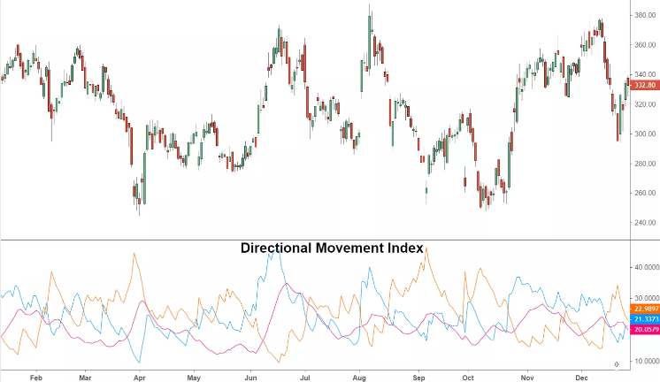

**Limitations of the DMI indicator:**

Despite its advantages, the DMI indicator also has some limitations:

* The DMI is part of the Average Directional Movement Index (ADX) system, where the DMI's trend direction can complement the strength readings of the ADX.
* ADX readings above 20 indicate strong price trending, regardless of whether you use ADX or not.
* Despite its integration with ADX, the DMI is still susceptible to generating false signals.
* +DI and -DI readings and crossovers are based on historical prices and may not accurately predict future price movements.
* A crossover between +DI and -DI may occur without the price responding accordingly, leading to losing trades.
* Lines of +DI and -DI can crisscross, resulting in multiple signals but no clear price trend.
* To mitigate this, traders may focus on trades aligned with the larger trend direction observed on long-term price charts or incorporate ADX readings to identify strong trends.

**Conclusion:**

In summary, the Average Directional Index (ADX) and Directional Movement Index (DMI) are must-have tools for traders dealing with the ups and downs of financial markets. ADX tells us how strong a trend is, while the +DI and -DI of DMI show which way the trend is going. By using these indicators, traders can figure out trends, see how strong they are, get signals for trading, confirm market moves, and handle risks. Still, it's important for traders to be careful and use other methods to double-check signals and adjust to changes in the market. This balanced approach is key to trading successfully.